March 2016
IT Showcase Productivity Guide

Skype for Business for Windows Phone
Customization note: This document contains guidance and/or step-by-step installation instructions that can be reused, customized, or deleted entirely if they do not apply to your organization’s environment or installation scenarios. The text marked by yellow highlighting indicates either customization guidance or organization-specific variables. All highlighted text in this document should either be deleted or replaced prior to distribution in your organization.

Microsoft Skype for Business for Windows Phone is an app that brings Skype for Business meetings, presence, instant messaging (IM), voice, and video capabilities to your mobile device. You can choose from multiple ways to communicate with others by using either Wi-Fi only or your cellular data connection when you’re not connected to Wi-Fi.
Important: Using the Skype for Business Mobile app can increase your mobile data usage. Depending on the type of mobile data plan you subscribe to, this might cause an increase in your mobile phone bill or slow your data connection speed.

Topics in this guide include:
Where to get Skype for Business for Windows Phone
Signing into Skype for Business for the first time
Participating in Skype for Business meetings
For more information
Using call forwarding and voicemail

Setting your status and a personal note

Working with contacts
Working with conversations

Where to get Skype for Business for Windows Phone
To get Skype for Business for Windows Phone, you need Windows Phone 8.1 or later. If you have a mobile device running Windows Phone 8.1 or later but do not have the Lync 2013 app, you can download the new Skype for Business app from the Windows Store. If you have Windows Phone 8.1 or later and currently have the Lync 2013 mobile app, downloading the new Skype for Business for Windows Phone app will replace your existing Lync 2013 app and tile automatically.
If you have a mobile device running Windows Phone 8.0, you will continue to use Lync 2013 or Lync 2010, which remains compatible even if your organization is running the new Skype for Business Server. Check periodically with your carrier to see if an upgrade to Windows Phone 8.1 is available for your mobile device so that you can replace Lync 2013 with the Skype for Business for Windows Phone app.
Important: Using the Skype for Business for Windows Phone app can increase your mobile data usage. Depending on the type of mobile data plan you subscribe to, this might cause an increase in your mobile phone bill or slow your data connection speed (for example, from 4G to 3G).

Signing into Skype for Business for the first time
Before you start Skype for Business for Windows Phone, make sure your phone is connected to the Internet through either your data plan or (preferably) a secure Wi-Fi network.
- On the sign-in screen, enter your user name (username@companyname.com) and password.
- Tap the check mark .
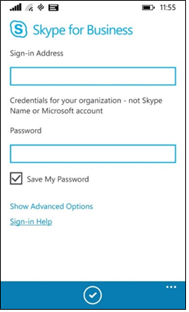
- The first time you sign in to Skype for Business for Windows Phone, enter your Windows Phone number with country/region codes (this should pre-populate any call forwarding or simultaneous ring settings that are set up in Skype for Business for the desktop). If Skype for Business cannot use the Wi-Fi or cellular data network to make an audio or video call, Skype for Business will call you back at this number to connect you to the audio portion of the Skype for Business call. When you’ve finished entering your number, tap Next .
- To receive an alert when a Skype for Business contact is trying to reach you, make sure Push notifications are On. To be able to search for and call contacts in your People hub from Skype for Business, make sure Allow phonebook access is set to On.
You can find other settings by tapping the ellipsis and choosing Settings. You might want to take a close look at these default settings:
- Voice Settings. Decide if you want to make Skype for Business audio and video calls only when connected through a Wi-Fi network or also when using your cellular data connection. Default voice settings are:
- VoIP always. By default, VoIP always is selected, which means that Skype for Business will use Wi-Fi to make Skype for Business calls. When you’re not connected to Wi-Fi, it will use your data cellular data connection or mobile minutes, instead.
- VoIP over Wi-Fi only. When VoIP over Wi-Fi only is selected, and you are not connected to Wi-Fi, Skype for Business will call you back and use your cellular minutes instead of your data plan.
- Cellular. When Cellular is selected, the app will always use your cellular minutes for voice calls, and neither Wi-Fi or data communication.
- Require Wi-Fi for video. By default, Require Wi-Fi for video is set to On. This means Skype for Business will use only Wi-Fi to make Skype for Business video calls. Video isn’t available for calls connected via your mobile number over the cellular voice network.
- Require Wi-Fi for video calls: Off
- Skype for Business might use your cellular data connection to send and receive video when you’re not connected to a Wi-Fi network. If you are connected to Wi-Fi, Skype for Business tries to use the Wi-Fi network for video, instead.
- Video isn’t available for calls connected via your mobile number over the cellular voice network
- Require Wi-Fi for video calls: On
- Skype for Business won’t use your cellular data connection to send or receive video.
- If you’re connected to a Wi-Fi network, Skype for Business tries to use Wi-Fi for video.
- Require Wi-Fi for Content. By default, Require Wi-Fi for meeting content is set to On. This means Skype for Business will use only Wi-Fi to make Skype for Business meeting content. Meeting content isn’t available for calls connected via your mobile number over the cellular voice network.
- Require Wi-Fi for meeting content: Off
- Skype for Business might use your cellular data connection to send and receive meeting content when you’re not connected to a Wi-Fi network. If you are connected to Wi-Fi, Skype for Business tries to use the Wi-Fi network for meeting content, instead.
- Require Wi-Fi for meeting content: On
- Skype for Business won’t use your cellular data connection to send or receive meeting content.
- If you’re connected to a Wi-Fi network, Skype for Business tries to use Wi-Fi for meeting content.
NOTE: To make changes to your settings at any time, tap the ellipsis and choose Settings.

Participating in Skype for Business meetings

Joining a Skype for Business meeting
To join a Skype for Business meeting, from the Meetings screen:
- Select the meeting you want to join.
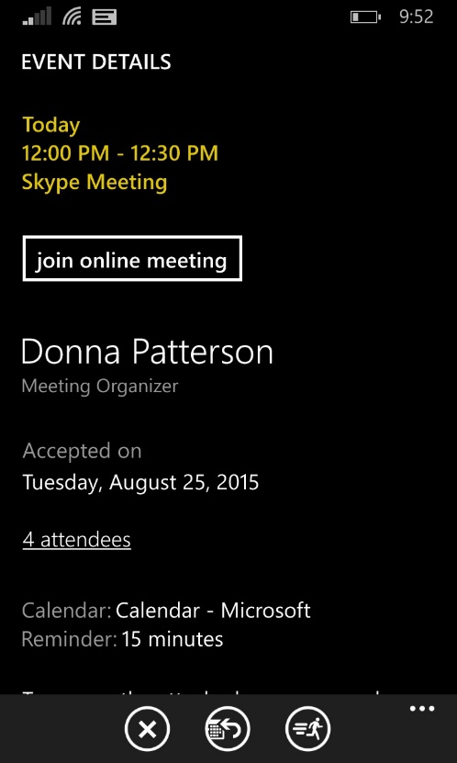
- Tap Join Meeting or the meeting hyperlink.
If you’ve joined a meeting from your mobile device, and you then join the same meeting from your desktop computer, you’ll stay connected to the meeting audio on your mobile phone and connect to the visual part of the meeting on your desktop computer. We recommend that you connect only to the meeting audio and video on either your mobile device or your desktop computer.

Waiting in the meeting lobby
The meeting lobby is an online waiting area. The meeting leader can control access to the meeting or admit someone who doesn’t have the correct meeting credentials. If the meeting leader has enabled the meeting lobby, you’ll need to wait until the meeting leader admits you to the meeting.
Important: If you’re waiting in the lobby, don’t switch to another screen. Your request to join the meeting will be cancelled if you do.

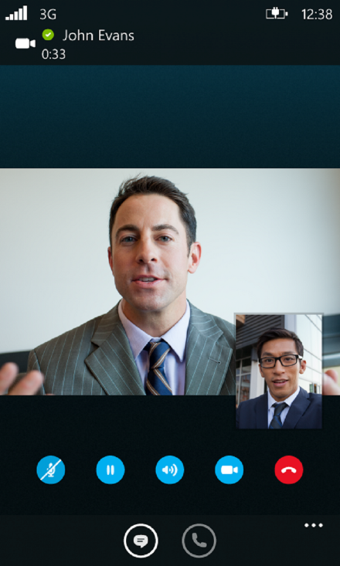
What you can do in a Skype for Business meeting

When you’re in a call, tap the:
- Mute icon to mute and unmute the call.
- Hold icon to put the call on hold, and then tap the Hold icon again to resume the call.
- Speaker icon to turn the speakerphone on and off.
- Dial pad icon to use the dial pad.
- End call icon to end the entire conversation.
- IM icon to view or send an instant message to people in the call, and then tap the Phone icon to go back to the audio conversation.
- Video icon to start your video.
When you’re in a video call, tap the Video icon and then tap one of the following:
- stop camera to turn off your video but still see another person’s video
- switch camera to switch from the front or back Windows Phone camera
- leave video to end everyone’s video for you only but still have audio
At the bottom of the screen, tap the ellipsis , then tap:
- leave conference to leave the meeting
- see participants to view the participants’ list in the meeting
- send as email to send an email copy of your conversation to someone
- see conversations to view current and past conversations

Setting your status and a personal note
Your presence information includes availability status, such as Available or Away, and is also indicated by a color-coded presence indicator, such as green, yellow, or red. When you are using Skype for Business on your mobile device, your status will indicate to people who view your contact information that you are currently using a mobile device.
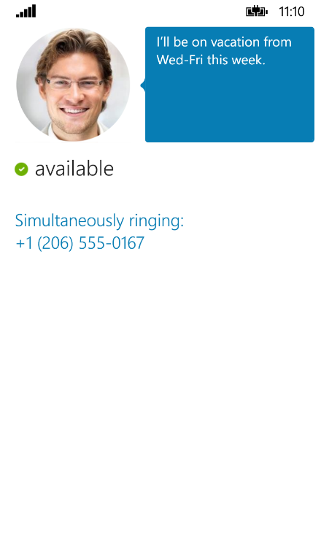

Setting your status
To change your status, tap your photo in the upper-right corner (a small, color-coded status indicator will be adjacent). Then, select your current status to choose one of the following presence statuses:
- Available
- Busy
- Do Not Disturb
- Be Right Back
- Appear Away
- Off Work
- Reset Status
- Sign Out

Automatic status updates
When you’re signed in, you remain signed in as long as there is connectivity. If you are in a meeting or on a call, your status is updated automatically. If you’re not actively using the app on your mobile device or Skype for Business on your computer, your status appears as Inactive. If you have connectivity but haven’t used the app for 10 days, you’re signed out and your status is Inactive.

Setting a personal note
Tap your photo with status in the upper right corner. In the note area, type any text you want. The note appears with your contact card. When you change your Automatic Replies (Out of Office) setting in Microsoft Outlook, the note you type there also appears in the personal note area in Skype for Business. This note stays in Skype for Business until you cancel the note in Outlook or type a new note.

Working with contacts

Finding a contact
- On the Contacts screen, tap Search , and then start typing a name, phone number, direct extension, or email address in the search box.
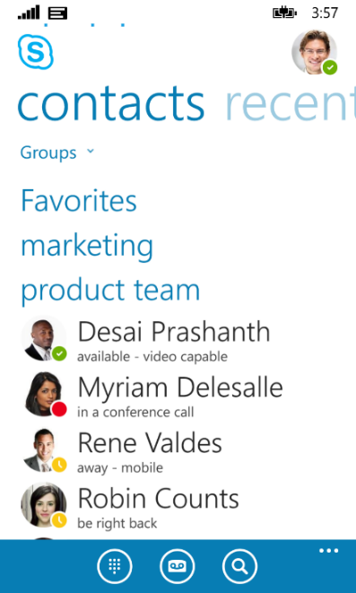
The results are displayed below the search box. If Phonebook Access is set to ON, when you search for a contact, the search results will also find contacts on your mobile phone. You can go to settings and set the Phonebook Access setting to on or off.

Viewing and editing your Contacts list
To view your Contacts list, go to the Contacts screen, and then tap any of the groups to expand the group. The Contacts list in Skype for Business on the desktop is the same as the one in the Skype for Business app. You can now add and remove contacts from the Contacts list in the mobile app.

Viewing someone’s contact card
The contact card displays status, a personal note, and office location about people and provides several ways to communicate with someone. For example, you can send an instant message, start an audio or video call, or send an email message directly—all from someone’s contact card. Find the contact in your Contacts list, or start typing a person’s name in the search box. When you find the contact you’re looking for, tap the person’s name and then tap the Contact card icon.

Working with conversations

Starting a conversation
- In Skype for Business, you can start a chat (IM), a voice call, or a video call with a single tap on a contact’s name.
- Type your message, and then tap the Send icon.
- You can also add audio or video to an existing IM conversation by tapping the Call or Video icon on the app bar.
- To call someone at their work or mobile number, tap their contact name and then tap the Contact card icon. Select the number you would like to call.

Joining a conversation
- IM. When someone sends you an instant message and you’re using Skype for Business, a notification appears at the top of the screen. To accept the invitation, tap the notification. If you receive an instant message while your phone is locked or Skype for Business is running in the background, a native Windows Phone notification appears, indicating that you have a new instant message. To accept the invitation, tap the notification. To ignore the invitation, just let the notification expire.
- Audio. When you get a Skype for Business call, it looks the same as any other call you get on your Windows Phone. The only difference is that when you get the call, the ringtone will be the default Skype for Business ringtone (this ringtone can’t be changed), and the incoming call screen will have a Skype for Business logo on the left.
- Video. When you receive a Skype for Business video call, tap video to accept an incoming audio and video call, or tap audio to accept an audio-only call.

Switching between conversations
To switch between conversations, at the bottom, tap the ellipsis and then tap See conversations. On the Conversions screen, tap the conversation you want to see.

Finding recent or missed conversations
To view a missed or recent conversation, go to the Recent screen. A list of recent and missed conversations is displayed. Tap the conversation to reply.

Deleting a conversation
To delete a conversation from the Recent screen, tap and hold the conversation you want to delete. When you see the menu options, tap delete conversation.

Using call forwarding and voicemail
You can set the call forwarding and simultaneously ring options so that you don’t miss calls. Call forwarding is especially useful if you’re traveling or working from home, because you can forward calls to your current location. If you’re out of the office, you can automatically forward calls to a co-worker.
The Simultaneously Ring option is handy for people on the go. When you get a call, it rings at two phone numbers at the same time. You can set your incoming calls to simultaneously ring your phone and another number or contact in case you’re busy or momentarily unavailable.

Forwarding calls
The Call Forwarding option is typically used to forward calls to voicemail or to a number other than your mobile number. When you set call forwarding settings in Skype for Business, all incoming calls are automatically forwarded to the destination you choose.
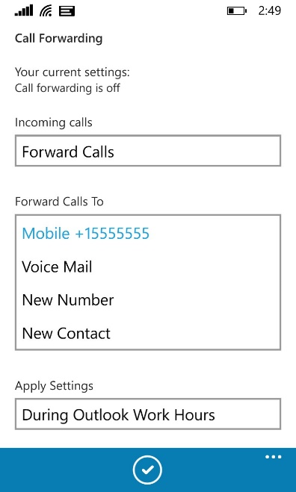

- In Settings, find Call Forwarding. Tap Forward Calls, and then complete one of the tasks:
- Tap Voice Mail to have the call sent to your voicemail, where you can retrieve it later.
- Tap and select a number you’ve added before, such as your mobile phone.
- Click New Number, and enter a new phone number.
- Tap New Contact, and then search for a contact in the dialog box that appears.
- Under Apply Settings, select the time period that you want this setting to apply to.
- Tap the check mark to save your changes.

Stopping call forwarding
To stop call forwarding, complete the following steps:
- On the Call Forwarding screen, tap Do not Forward calls.
- Under Apply Settings, select the time period that you want this setting to apply to.
- Tap the check mark to save your changes.

Setting up Simultaneously Ring
Unlike call forwarding, where your work phone doesn’t ring, you can set your incoming calls to simultaneously ring your phone and another number or contact. This setting can help ensure that callers don’t get a busy signal and you don't miss their calls. At the same time, callers won’t be aware that their call was forwarded.
- On the Call Forwarding screen, tap Simultaneously Ring, and then do one of the following:
- Tap New Number and enter a new phone number.
- Tap and select a phone number you’ve added before, such as your mobile phone.
- Under Apply Settings, select the time period that you want this setting to apply to.
- Tap the check mark to save your changes.

Using voicemail
Your voicemail messages are saved in both Skype for Business and Outlook. When you have new voicemail, the voicemail icon at the bottom of the screen displays the number of messages. To listen to a voicemail message, tap the voicemail icon and then play the message. To reply to the message, tap it to open the sender’s contact card and reply using IM, an audio call, or a video call.

For more information
For more information about Microsoft products or services in the United States, call the Microsoft Sales Information Center at (800) 426-9400. In Canada, call the Microsoft Canada Order Centre at (800) 933-4750. Outside the 50 United States and Canada, please contact your local Microsoft subsidiary. To access information via the web, go to:
http://www.microsoft.com

Microsoft IT Showcase
http://www.microsoft.com/ITShowcase

For more great productivity guidance, visit…
http://microsoft.com/ITShowcase/Productivity
© 2016 Microsoft Corporation. All rights reserved. Microsoft and Windows are either registered trademarks or trademarks of Microsoft Corporation in the United States and/or other countries. The names of actual companies and products mentioned herein may be the trademarks of their respective owners. This document is for informational purposes only. MICROSOFT MAKES NO WARRANTIES, EXPRESS OR IMPLIED, IN THIS SUMMARY.

